Building your Allocated Component

Building your Allocated Component 1
Revisit your System Specifications 1
Copy and Adapt 1
So where do we go next? 1
The GitHub Workflow 2
Create a clean folder for this work cycle 3
Clone the repository to the folder 3
Create a new branch (Don’t edit the master directly) 7
Do some work on your part of the system 11
Save your work 13
Scan for changes 13
Add notes 15
Commit changes 15
Sync 15
Go to Git 16
Create a new pull request (complete the process with appropriate comments from another team member) 17
Delete branch 19
Delete the local folder you created at the start of the day 19
Diving in 19
Creating the Properties 20
Adding the Presentation Layer 26

Building your Allocated Component

Revisit your System Specifications
Remember at the start of the module you created system specifications identifying what your application is going to do and who is allocated which section?
Now is the time to return to these documents to remind you of who is working on what component.
I will continue to use my address book examples but remember you don’t simply copy my examples, you need to copy and adapt such that it meets your personal requirements.

Copy and Adapt
One approach we will use to introduce programming concepts is copy and adapt.
The idea is that I present you with an example from my own design and then you need to adapt that design to match your own requirements.
For example, if you are creating a system to manage staff you need to look at my address book code and adapt it such that it follow your own requirements not mine. If I say clsAddress you need to create clsStaff etc..

So where do we go next?
We will implement the class pair clsAddressCollection and clsAddress
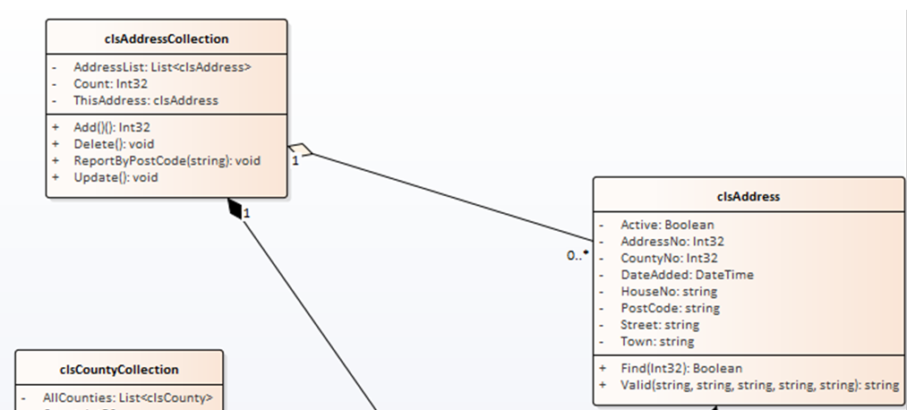
As above let’s start with something simple. Since clsAddressCollection uses clsAddress we will start with clsAddress.
The problem we have now is that via GitHub you will all be working on your systems as a team so we need to establish a work flow such that you don’t keep treading on each other’s toes.

The GitHub Workflow
Here is a quick check list of the GitHub workflow we will use as you work together...
Initial Setup (You should all have done this by now!)
- Set up the local skeleton system for the team project containing one class library, one test project a customer facing front end and a staff facing back end
- Make sure this compiles and the folder structure is correct
- As a team select one person to host the master repository on GitHub
- Invite team members to collaborate
- Add the local system skeleton to source control such that the code is in the master repository
- Each member should test that they are able to make a clone of the skeleton system and that the folder structure is identical for each team member
- Remember – the master repository is sacred do not edit directly
The next stage is to forget that you are a student and start thinking like an employed software developer.
Imagine now that you work within a company, clock in at nine o’clock and leave at five.
At 9am you start the working day
- Create a clean folder for today’s work cycle
- Clone the repository to the folder
- Create a new branch (NEVER edit the master directly)
- Do some work on your part of the system
At 5pm you finish the working day
- Save work
- Scan for changes
- Add notes
- Commit changes
- Sync
- Push
- Go to Git
- Create a new pull request (complete the process with appropriate comments from another team member)
- Delete branch
- Delete the local folder you created at the start of the day
IMPORTANT!
When you are working on code within your own local branch, that code is unavailable to other members of your team until you have pulled the changes into the master branch.
There are two issues to think about here.
- Never put code into the master that is buggy or doesn’t compile, this is a really good way of spreading bad code to your team members
- Keep the life of your branches short. What I mean is complete a small section of work, say create a few tests with corresponding changes to the class library then merge the new code with the master once you are confident it is debugged and free of compilation errors.
- 24 hours is a long time in Git. The longer you sit on code in your own branch the longer other team members have to wait to access your code.
- Always talk to each other! Let each other know what work you are about to undertake such that you may anticipate any potential problems.
As above, we will start with the most basic test i.e. creating an instance of the required class. This time we will do it within the context of the GitHub work flow.

Create a clean folder for this work cycle
This should be the easy bit. When starting this cycle of work you must not start working on an old copy of your work, why? While you have not been working it is likely that other team members have made changes to the system. If this is potentially the case then you must start with a clean copy of the system, so best to clone this to a new empty folder. I tend to like to create my own so I know where it is the file system like so...
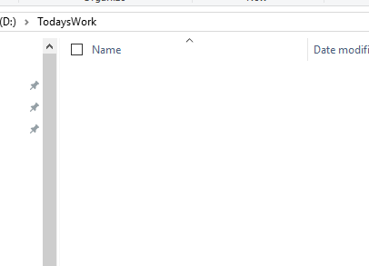

Clone the repository to the folder
To clone the master repository you will need to know the URL of the repository.
This is available from the repository under Clone or Download...
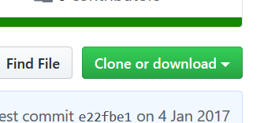
Like so...
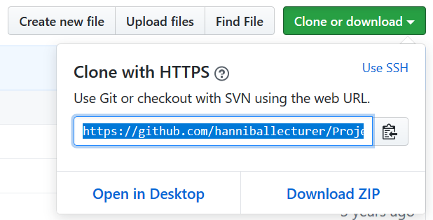
You will need to then start Visual Studio.
Once Visual Studio is open you will need to access the Team Explorer on the right of the interface...
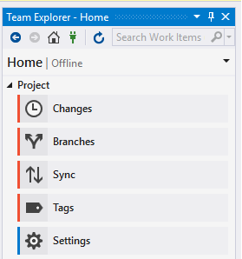
To clone the repository you need to connect to GitHub using the green connect icon...

From here, select the option for cloning the repository...
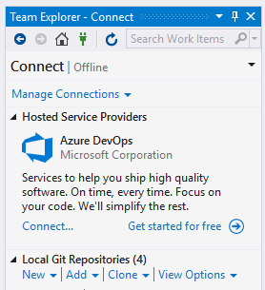
Enter the URL of the repository along with the path of the folder you plan to work in...
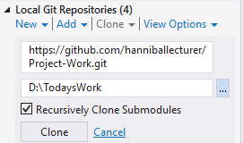
Then press Clone.
After a little while you should see the solution listed in Team Explorer...
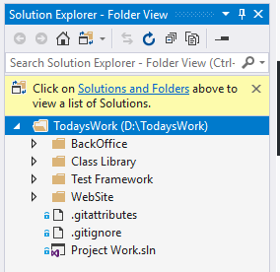
Also if you look at the folder for today’s work you will see that the files have been cloned to the local PC...
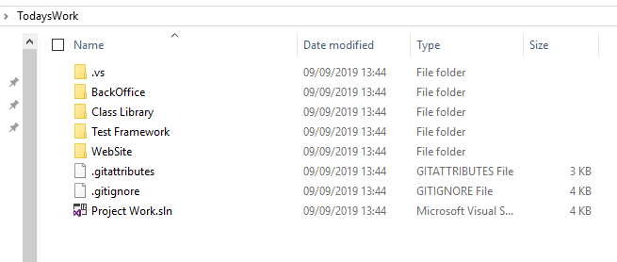
To open the solution, double click the solution file in Visual Studio...
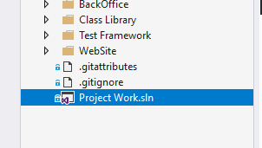
You should now see all projects listed in the solution explorer...
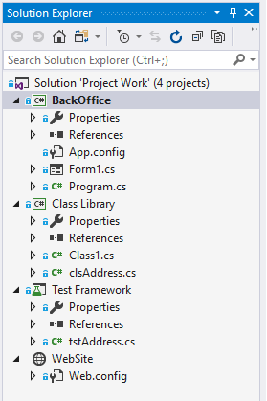

Create a new branch (Don’t edit the master directly)
As things stand you have a copy of the master repository, if you edit this you will be directly editing the system and potentially create problems for your team members.
The only time you edit the master repository directly is for high level admin operations ensuring that there are no active branches open on the work.
To do today’s work you need to create a new branch for yourself to isolate your changes from the code belonging to other members.
In Visual Studio under Team Explorer select home and then branches...
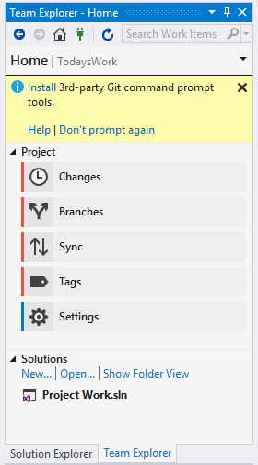
You should see on the next screen that the master branch is selected...
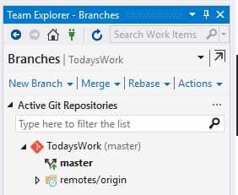
Right click on the master branch and select “new local branch from...”
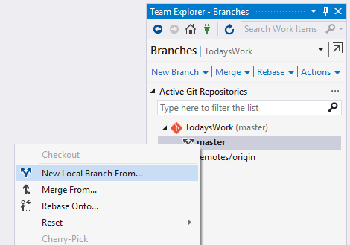
Click this option and enter a name for your local branch...
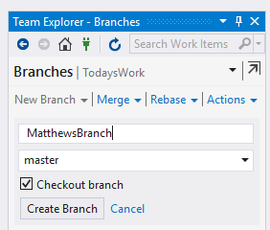
Next select “Create Branch”.
To create the branch on GitHub you also need to push the branch to the remote server.
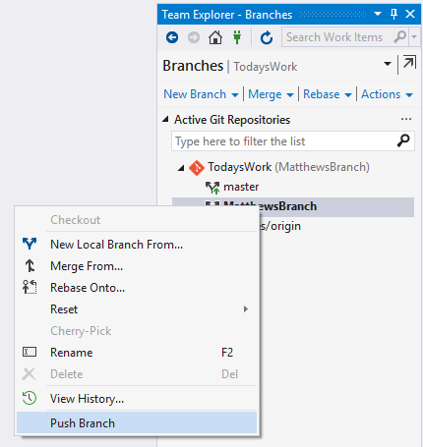
Visual Studio is likely to ask for your GitHub user name and password.
The branch has now been created locally and also on the server, this way your other team members know that you are working on something.
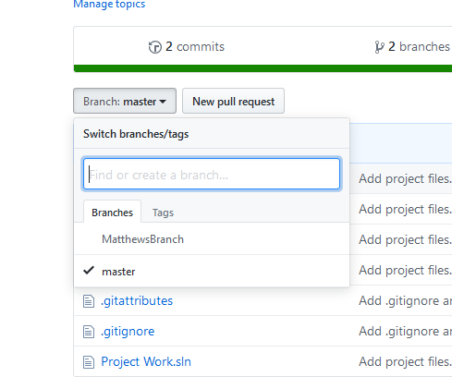

Do some work on your part of the system
Let’s create a test class…
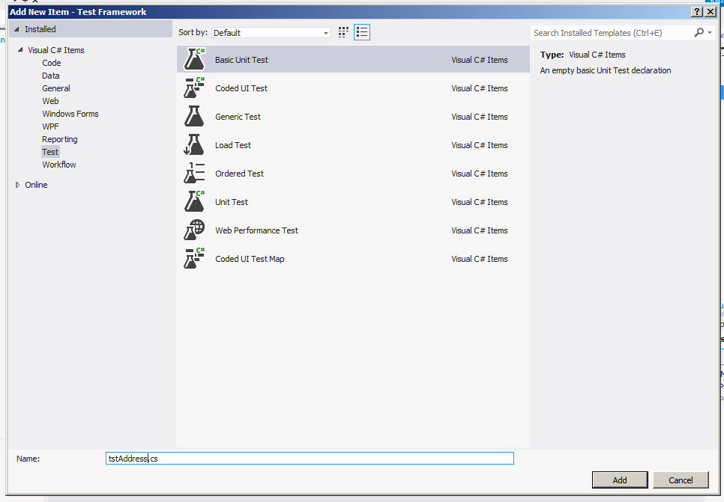
In this example I am creating a class for my address book (tstAddress). In your case you need to create a new class for your selected system component. If you are working on staff management you would create tstStaff, if you are working on stock, tstStock etc.
Next create the test for instantiation…
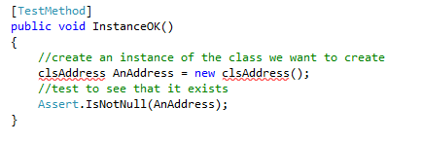
Then watch it fail…
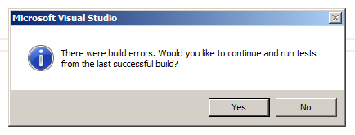
(Always press no here!)
To fix the problem we need to create the class file.
Hold the mouse over the red underlining and wait for the following menu to appear…
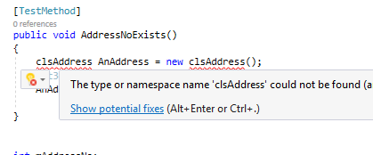
Click on “Show potential fixes” and this screen should appear…
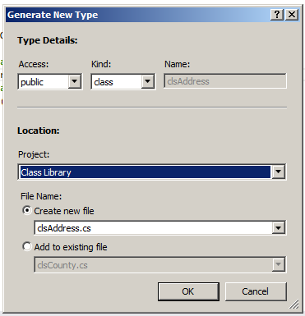
Make sure the setting are correct and that you are creating the class in your class library.
You should now see the test pass…
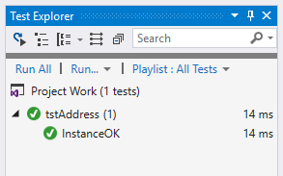
That’s enough work for one day!

Save your work
Make sure everything is saved in Visual Studio.
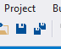

Scan for changes
From the home of Team Explorer select Changes...
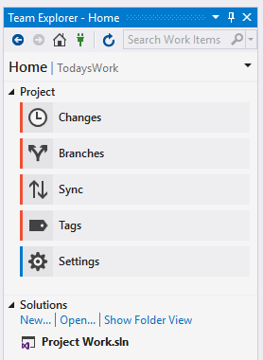
Visual Studio will look at the code you have written and should identify that there have been changes to the system like so...
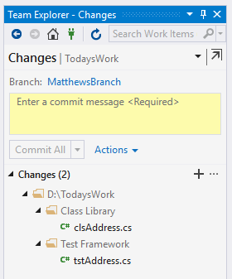

Add notes
Before you are able to do anything else you need to add some notes explaining what you have changed. The idea is that you leave a paper trail so that other people know what has been changed in the system and by whom.
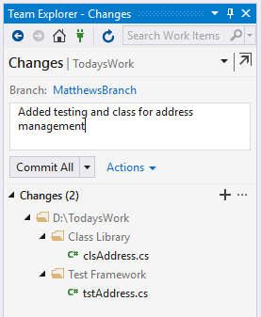

Commit changes
You should now be able to commit the changes.
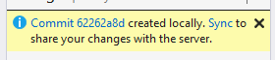
This has told the local system to accept the changes. In order for the changes to appear in GitHub you will next need to sync the changes with the server.

Sync
So far the local branch is aware of your changes, selecting Sync tells the main Git server about what you have changed.
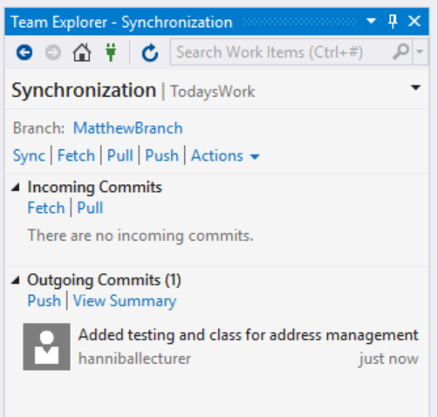
Finally push your changes to the remote repository...
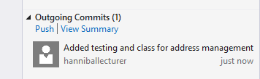

Go to Git
The next step is to check that the changes have been copied over to GitHub.
If you look at the repository you should see that the master branch and your own branch are listed...
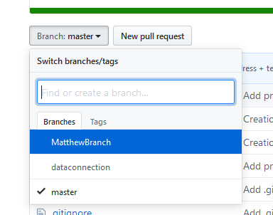
Select the new branch, not the master.
You should be able to see all of the changes listed in the repository...
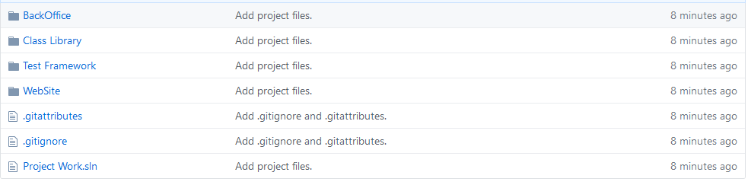

Create a new pull request (complete the process with appropriate comments from another team member)
We now want to take the branch on GitHub and merge it back into the master branch, to do this we need to create a new pull request...
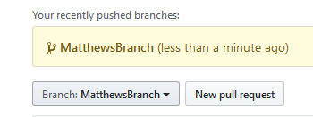
Press the button to create the pull request and you should see the following screen...
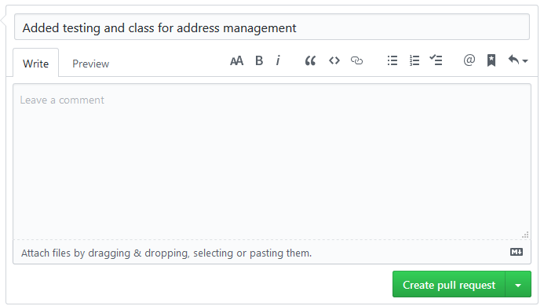
The idea here is that you ask another team member to review the changes and confirm that you are not adding bad code to the main repository. Once you are both happy you may add some comments.
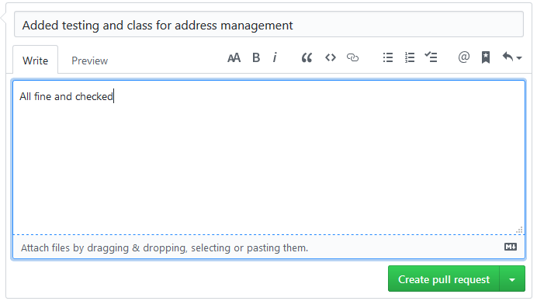
The select create pull request.
GitHub will check to see if there are any conflicts, hopefully not...
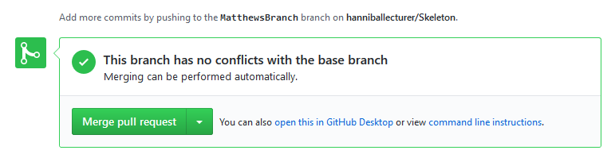
If there are conflicts you will have to resolve them (this is where the fun begins and why it is good to talk to each other!)
If all is well select merge pull request followed by confirm merge (you have to really mean it!)
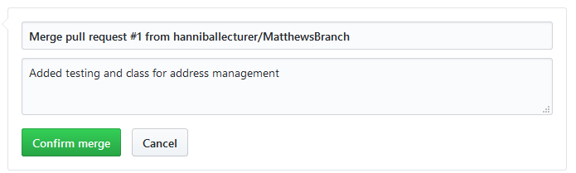

Delete branch
Once the pull request is completed you need to delete your branch...
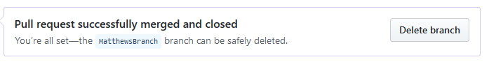

Delete the local folder you created at the start of the day
I would also suggest that you tidy up your local machine by deleting or archiving your local folder.

Diving in
Having established the work you need to undertake it is down to you as a team to dive in and have a go yourselves. You need to complete your own components using the following notes as a guide. Remember you need to adapt what I give you to match what you are building and also keep in mind the work-flow.

Creating the Properties
Let’s set about creating the properties for the class we created above (don’t forget to make a new clone as other people may have changed the code while you were doing something else!)
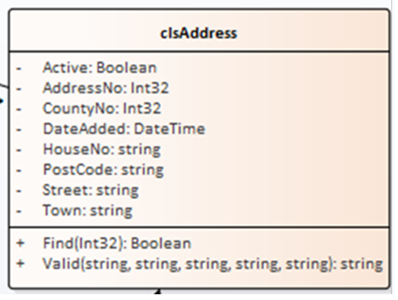
Create a test for the first property…
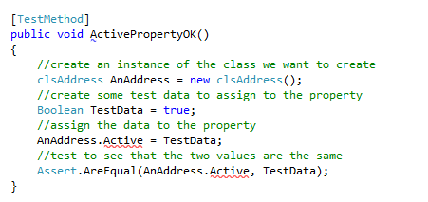
Watch it fail…
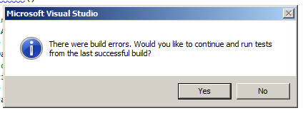
Fix the problem by holding the mouse over the red underlining…
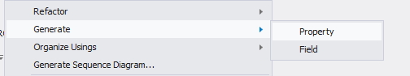
Make sure the test passes…
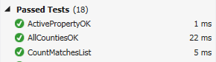
The next property we shall look at is DateAdded as it allows us to look at some useful code.
Take a look at the test code for this date property…
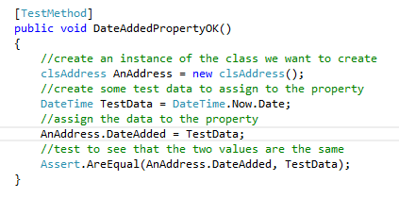
The thing about date tests is that we don’t want to be updating the date every time we run the test.
The following line of code gets round this problem.
DateTime TestData = DateTime.Now.Date;
What it does is assign the variable TestData with today’s date taken from DateTime.Now.Date
You will need to create the rest of the tests such that all of the properties are tested and created.
The code for the test class for all properties is as follows…

using System;
using Microsoft.VisualStudio.TestTools.UnitTesting;
using Class_Library;

namespace Test_Framework
{
[TestClass]
public class tstAddress
{
[TestMethod]
public void InstanceOK()
{
//create an instance of the class we want to create
clsAddress AnAddress = new clsAddress();
//test to see that it exists
Assert.IsNotNull(AnAddress);
}

[TestMethod]
public void ActivePropertyOK()
{
//create an instance of the class we want to create
clsAddress AnAddress = new clsAddress();
//create some test data to assign to the property
Boolean TestData = true;
//assign the data to the property
AnAddress.Active = TestData;
//test to see that the two values are the same
Assert.AreEqual(AnAddress.Active, TestData);
}

[TestMethod]
public void DateAddedPropertyOK()
{
//create an instance of the class we want to create
clsAddress AnAddress = new clsAddress();
//create some test data to assign to the property
DateTime TestData = DateTime.Now.Date;
//assign the data to the property
AnAddress.DateAdded = TestData;
//test to see that the two values are the same
Assert.AreEqual(AnAddress.DateAdded, TestData);
}

[TestMethod]
public void AddressNoPropertyOK()
{
//create an instance of the class we want to create
clsAddress AnAddress = new clsAddress();
//create some test data to assign to the property
Int32 TestData = 1;
//assign the data to the property
AnAddress.AddressNo = TestData;
//test to see that the two values are the same
Assert.AreEqual(AnAddress.AddressNo, TestData);
}

[TestMethod]
public void CountyNoPropertyOK()
{
//create an instance of the class we want to create
clsAddress AnAddress = new clsAddress();
//create some test data to assign to the property
Int32 TestData = 1;
//assign the data to the property
AnAddress.CountyNo = TestData;
//test to see that the two values are the same
Assert.AreEqual(AnAddress.CountyNo, TestData);
}

[TestMethod]
public void HouseNoPropertyOK()
{
//create an instance of the class we want to create
clsAddress AnAddress = new clsAddress();
//create some test data to assign to the property
string TestData = "21b";
//assign the data to the property
AnAddress.HouseNo = TestData;
//test to see that the two values are the same
Assert.AreEqual(AnAddress.HouseNo, TestData);
}

[TestMethod]
public void PostCodePropertyOK()
{
//create an instance of the class we want to create
clsAddress AnAddress = new clsAddress();
//create some test data to assign to the property
string TestData = "LE1 4AB";
//assign the data to the property
AnAddress.PostCode = TestData;
//test to see that the two values are the same
Assert.AreEqual(AnAddress.PostCode, TestData);
}

[TestMethod]
public void StreetPropertyOK()
{
//create an instance of the class we want to create
clsAddress AnAddress = new clsAddress();
//create some test data to assign to the property
string TestData = "Some Street";
//assign the data to the property
AnAddress.Street = TestData;
//test to see that the two values are the same
Assert.AreEqual(AnAddress.Street, TestData);
}

[TestMethod]
public void TownPropertyOK()
{
//create an instance of the class we want to create
clsAddress AnAddress = new clsAddress();
//create some test data to assign to the property
string TestData = "Leicester";
//assign the data to the property
AnAddress.Town = TestData;
//test to see that the two values are the same
Assert.AreEqual(AnAddress.Town, TestData);
}
}
}

Adding the Presentation Layer
In order to prove that this is working let’s add a simple web interface to capture some data from the user and pass it to a second form.
Right click on the customer facing web site and add a new item...
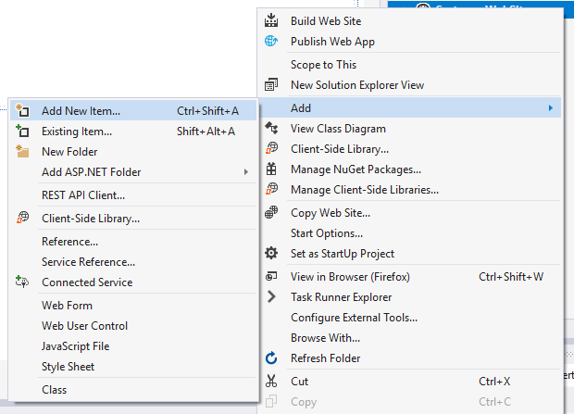
Set up a new web form called AnAddress.aspx like so...
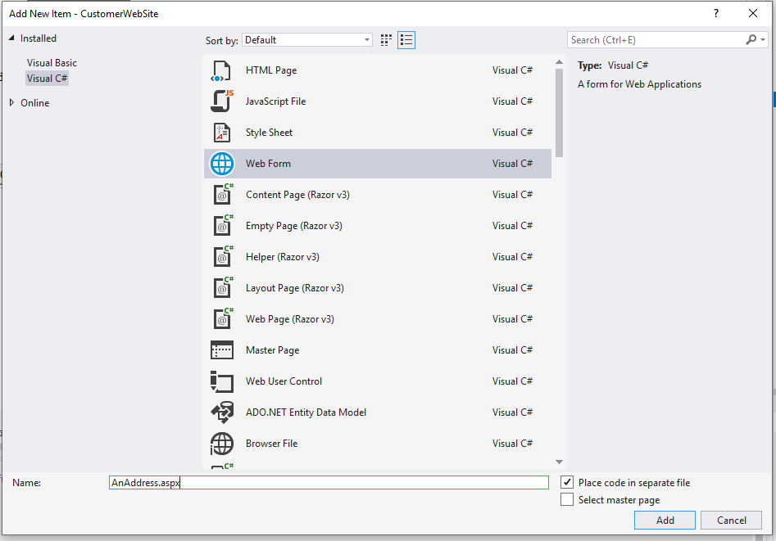
In design view set up the controls like so...
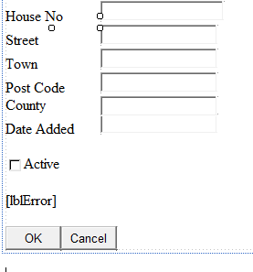
Don’t forget to set up the control names using a suitable naming convention, e.g. txtHouseNo etc..
Access the click event handler for btnOK, you should see the following...
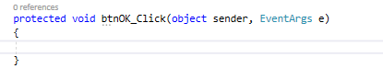

Linking the Middle Layer
Before you add any code to the button you will need to set up the page so that it knows where the code for the middle layer is.
Right click on the web site and select the following…
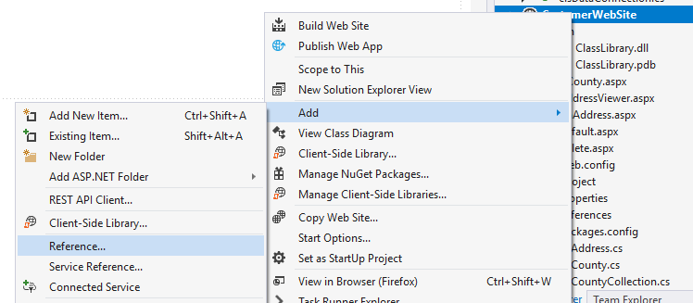
You should see the following page…
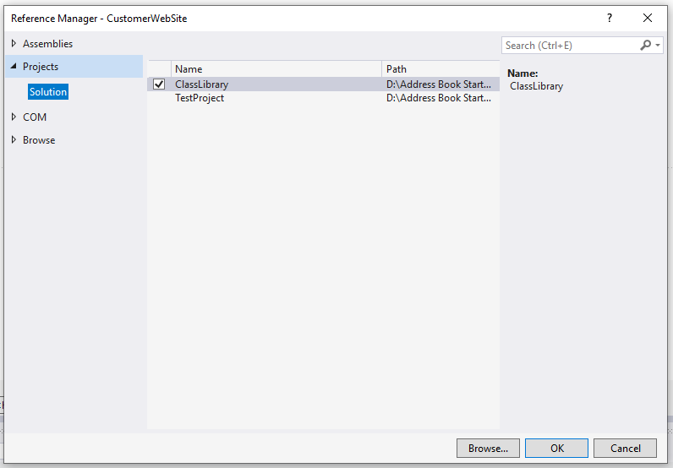
Under Solution you should see your class library listed, make sure there is a tick beside it and press OK.
Lastly at the top of the code where you added the following…
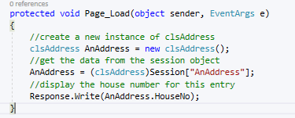
Make sure there is a “using” telling the page to use your class library…
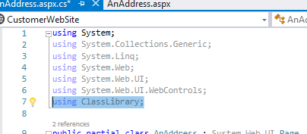

Setting the Start Project and Start Page
You also need to make sure the web site is set as your start project. Right click on the web site and select set as start-up project.
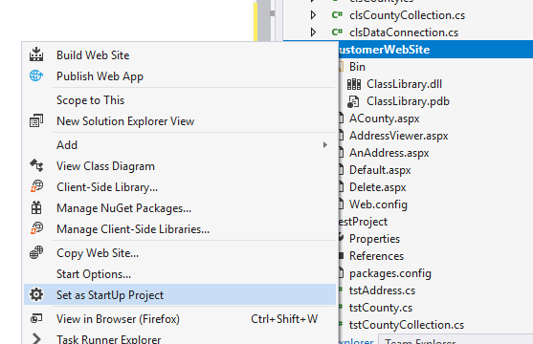
Lastly right click on the web page AnAddress.aspxand make it the start page for the project like so…
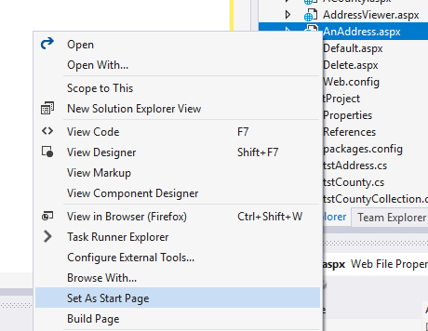

If everything is set up correctly you should be able to add the following code...
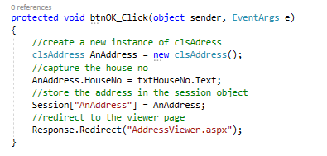
Next create the viewer page. Add a new web form and set it up like so...
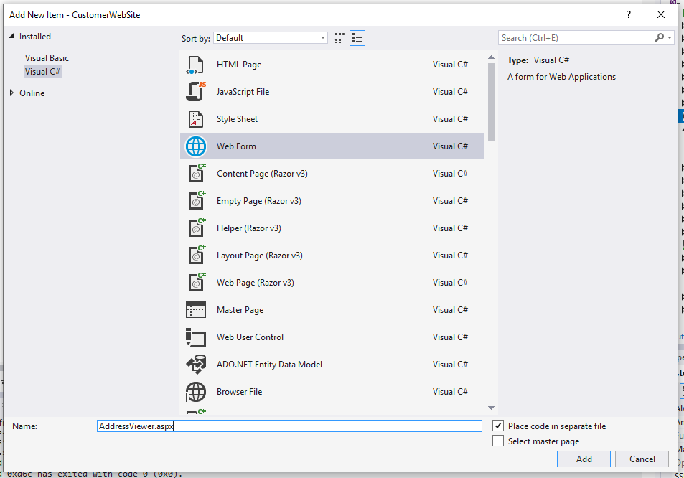
Open the page in design view and double click the page to access the load event of the page...
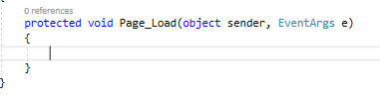
Add the following code to the load event...
Here is the finished version of my code for the click event for later reference…
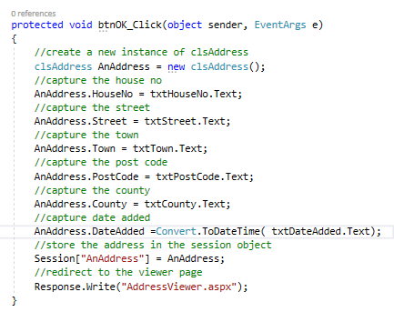
Run the program and you should see the address data entry page displayed...
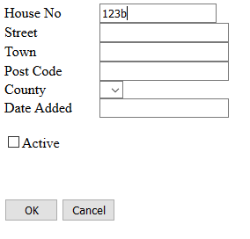
Enter some data as above.
Press OK and the viewer page should be displayed.
Modify the above code such that you are able to input values for all of the attributes of the class. Do note that as yet the data is not validated so entering bad data will crash the program.

